**ASM Configuration**

**Prerequisites:-**

**Step 1:**

* Set up Oracle Database Server on VMware Workstation using( OEL) Linux 7.6 OS Platform?

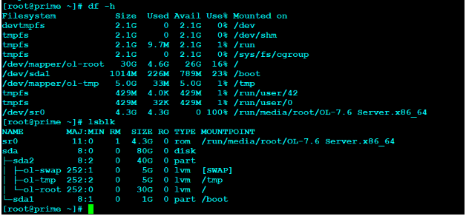

**Step 2: Connect to OEL 7.6 server via putty and install the below packages**

|  |  |
| --- | --- |
|  | yum -y install -y oracle-database-preinstall-19c |

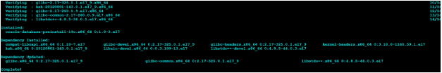

* yum -y install oracleasm*

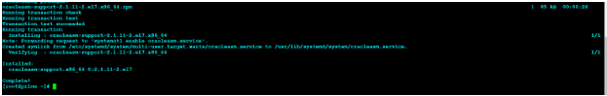

* yum -y install kmod-oracleasm*

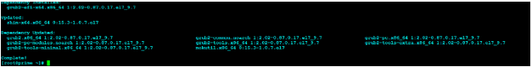

**Add below OS groups :**

|  |  |
| --- | --- |
| 1  2  3 | groupadd -g 54327 asmdba  groupadd -g 54328 asmoper  groupadd -g 54329 asmadmin |



**Add asmdba as secondary group to Oracle user**

|  |  |
| --- | --- |
|  | usermod -a -G asmdba oracle |



**Create Grid User**

|  |  |
| --- | --- |
|  | useradd -u 54331 -g oinstall -G dba,asmdba,asmoper,asmadmin,racdba grid |



**Change the password for Oracle and Grid user**

|  |  |
| --- | --- |
|  | passwd oracle |

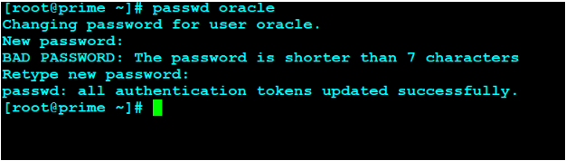

* passwd grid

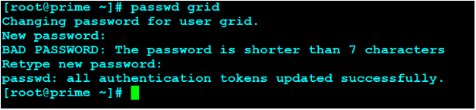

**Create the Directories for Oracle Database installation**

|  |  |
| --- | --- |
| 1  2  3 | mkdir -p /u01/app/oracle  mkdir -p /u01/app/oracle/product/19.3.0/db_home  chown -R oracle:oinstall /u01/app/oracle |

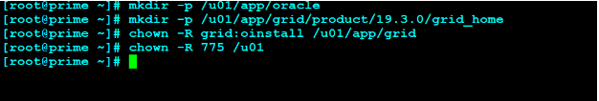

Create the Directories for Oracle Grid installation

|  |  |
| --- | --- |
| 1  2  3 | mkdir -p /u01/app/grid/product/19.3.0/grid_home  chown -R grid:oinstall /u01/app/grid  chmod -R 775 /u01 |



**Configure Oracle ASM**

**Let us configure Oracle ASM**

|  |  |
| --- | --- |
|  | oracleasm configure -i |

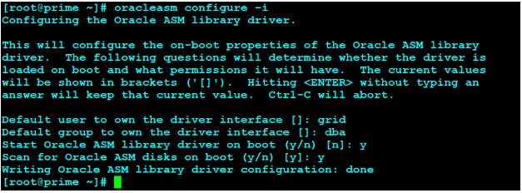

**Load / initiate Oracle ASM**

* Fire oracleasm init

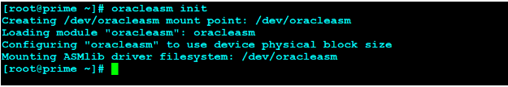

**Add 30 GB HDD to virtual machine which we will use to create 3 partitions of 10 GB each for our ASM disks. Open Virtual machine**

**Stop the server go to >> Settings >> Storage >> Controller: SATA >> Create new disk**

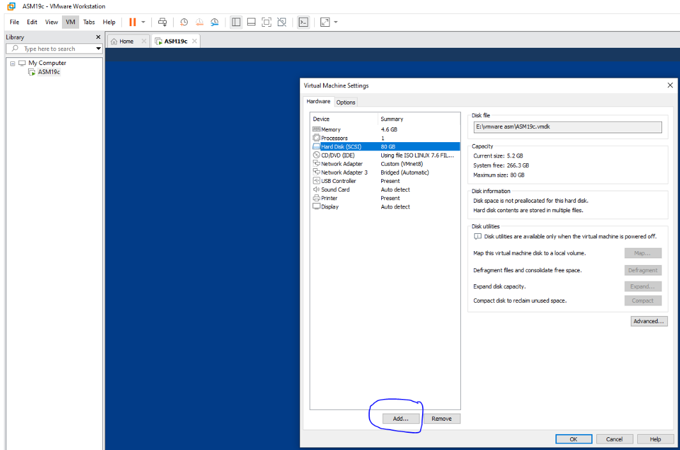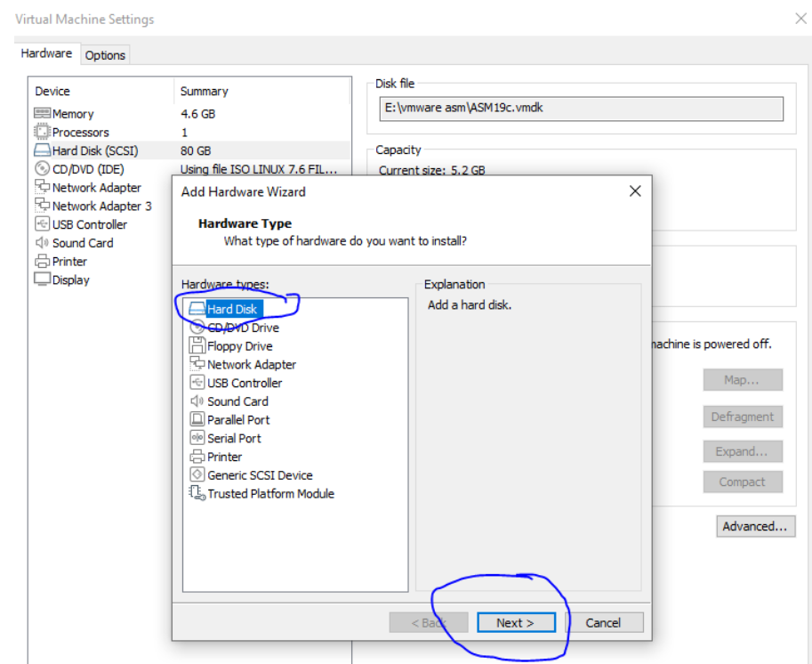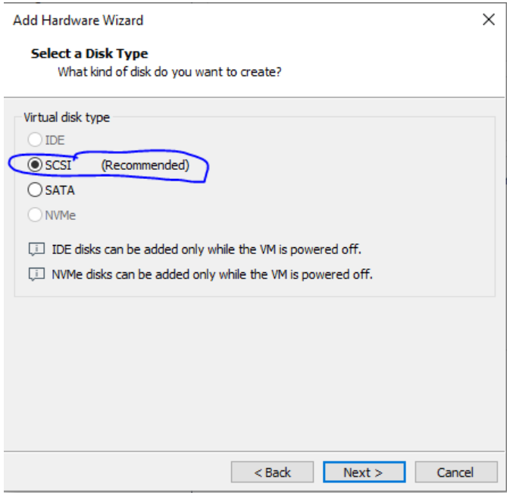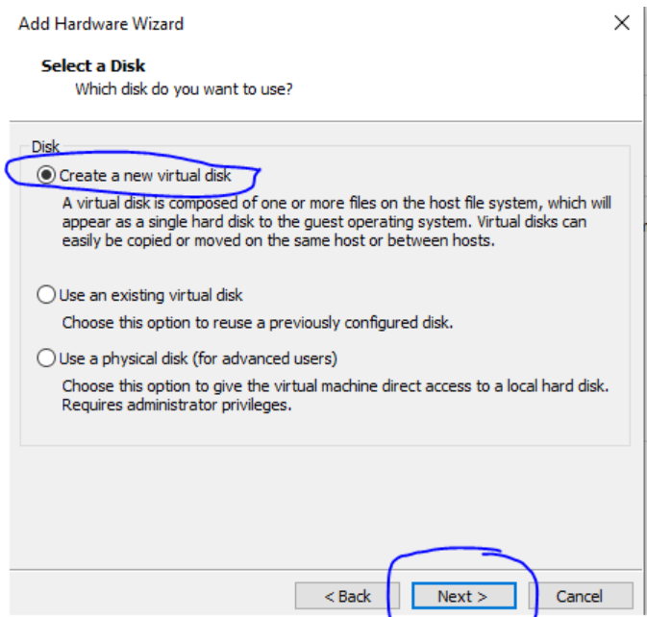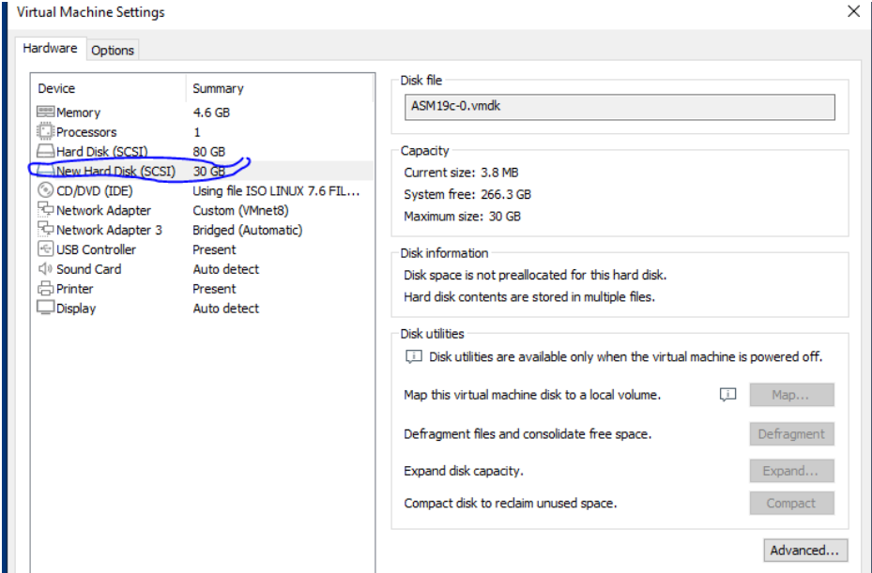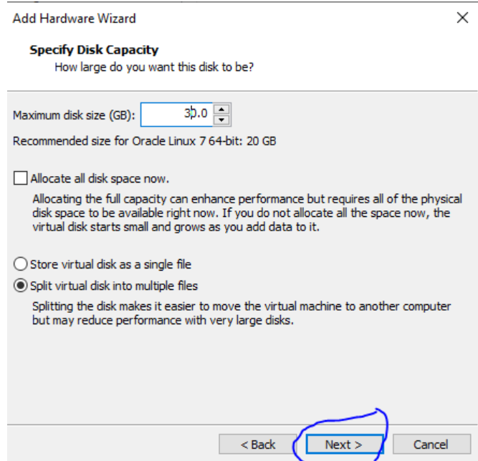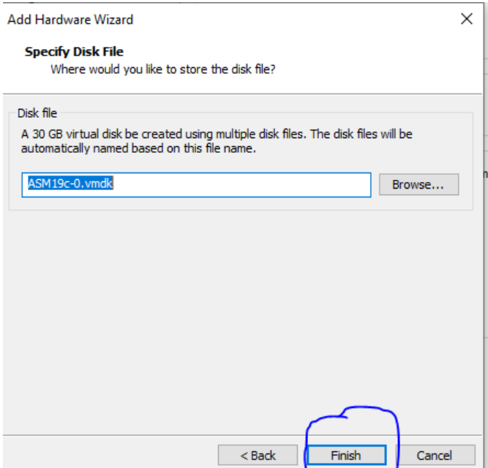

**create 3 partitions of 10 GB each for our ASM disks**

login as root user to format the  disk

|  |  |
| --- | --- |
|  | fdisk -l |

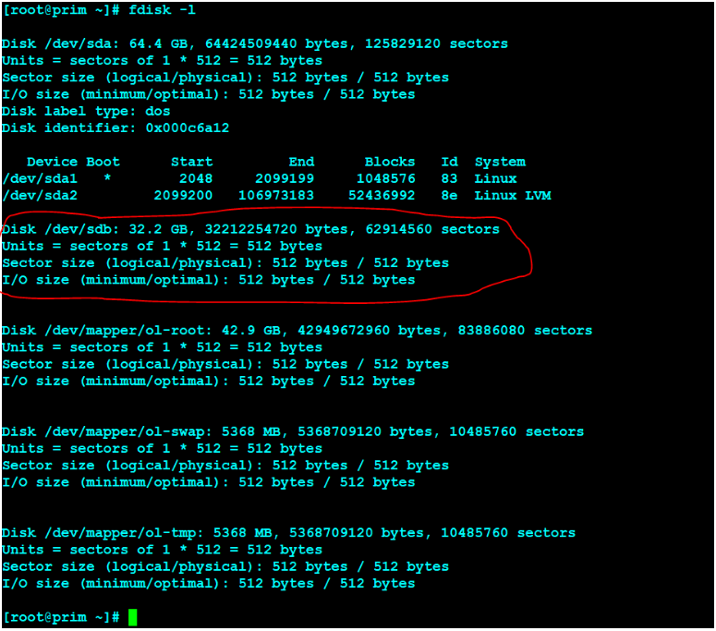

**In the above output the /dev/sdb is not yet formatted. Let’s create 3 partitions on sdb**